Chapter 6A: Classic Bluetooth – The Wireless Serial Port Profile (SPP)

Time: 2 ½ Hours

At the end of this chapter you will understand the basics of Classic Bluetooth and how to create a simple Classic Bluetooth project on WICED devices. This section is focused on the simplest Bluetooth connection, one Master (Android, Mac or PC) and one Slave (your WICED Bluetooth Device). By the end you should understand Inquiry, Page, Pair, Bond, SDP, L2CAP, RFCOMM and the Serial Port Profile (SPP).

6A.1 WICED Bluetooth Classic System Lifecycle Overview 2

6A.1.1 Inquiry 4

6A.1.2 Page / Connect 4

6A.1.3 Discover the Services using Service Discovery Protocol (SDP) 4

6A.1.4 Pair & Bond 4

6A.1.5 Exchange Data with the Serial Port Profile 5

6A.2 Service Discovery Protocol (SDP) 5

6A.3 Secure Simple Pairing 6

6A.4 L2CAP, RFCOMM & the Serial Port Profile 6

6A.4.1 L2CAP 8

6A.4.2 RFCOMM 8

6A.4.3 Serial Port Profile 8

6A.5 WICED Bluetooth Designer 9

6A.6 WICED Bluetooth Stack Events 16

6A.7 WICED Classic Bluetooth Firmware Architecture 17

6A.7.1 Overview 17

6A.7.2 Application Code (<appname>.c) 17

6A.7.3 SDP Database (<appname>_sdb_db.c/.h) 18

6A.7.4 Handle Pairing 19

6A.7.5 Handle Bonding 20

6A.7.6 Support the Serial Port Profile 22

6A.8 Exercises 27

Exercise - 6A.1 Create a Serial Port Profile Project 27

Exercise - 6A.2 Add UART Transmit 40

Exercise - 6A.3 (Advanced) Improve Security by Adding IO Capabilities (Yes/No) 41

Exercise - 6A.4 (Advanced) Add Multiple Device Bonding Capability 42

# WICED Bluetooth Classic System Lifecycle Overview

The Bluetooth Classic Spec has a bewildering amount of complexity. Clearly this must have been one of the motivations for creating the much simpler BLE standard. Like Chapter 4 we will take the approach of creating the simplest example project possible to get things going.

The simplest Bluetooth Classic scenario has two devices, a Master and a Slave. Slaves are passive – not transmitting – until they hear an Inquiry broadcast from a Master, at which point the Slave broadcasts basic information about itself (Name, BDADDR, Services). The Master then Pages (connects) to the Slave and discovers the Services - i.e. the capabilities of the Slave. If the Master is interested, they will establish a secure link which includes Pairing on the first connection. Finally, a service level connection is established which in the simplest case is the Serial Port Profile.

The five steps are:

1. Inquiry – Master finds a Slave to Connect
2. Paging – Master connects to Slave
3. Service Discovery (SDP) – The Master figures out what the Slave can do
4. Pair & Bond – A secure, authenticated connection is created
5. Establish SPP connection and Exchange Data using the Serial Port Profile

The architecture of a Bluetooth Classic device is essentially the same as that of a BLE device. It is composed of five layers.

|  |  |  |
| --- | --- | --- |
|  | Application | The code that you write to implement your system functionality. |
| Bluetooth Classic Stack | Profile Library | Source libraries including implementation of standard Bluetooth Profiles such as SPP. |
| Host Stack | Provides multiple connection paths to the application each with its own features (reliable, ordered, time critical, etc.). It also provides Services to the local and remote application. |
| Controller | Establishes and maintain links between devices. |
| Hardware | Radio | RF magic & the best reason to use Cypress chips. |

Here is the overall picture of the simplest Bluetooth Classic system:

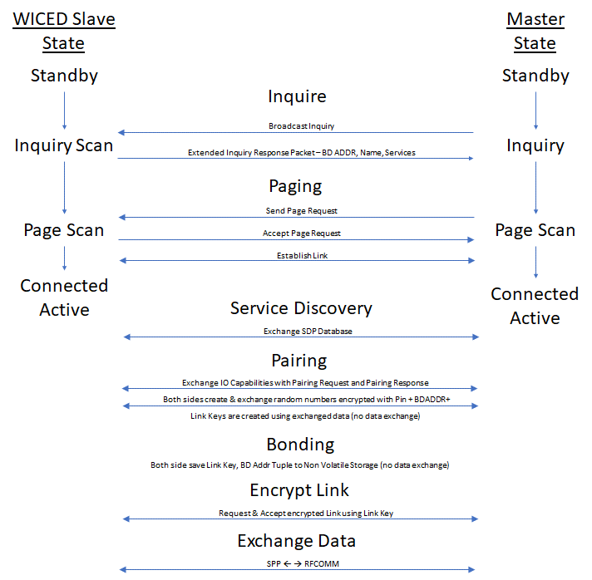

## Inquiry

The purpose of the Inquiry process is for a Bluetooth Master to find all the Bluetooth Slaves that are within its radio range that might provide some interesting Service. This is exactly the opposite of BLE where a Peripheral advertises it availability and the BLE Central Scans for those packets.

A Bluetooth Classic Slave sits in state called Inquiry Scan - i.e. a listening only state - until it hears a Bluetooth Master broadcast an Inquiry Request message. The Slave Application is responsible for putting the Stack into the Inquiry Scan state using the correct Stack API.

Upon hearing an Inquiry Request the Slave will broadcast an Extended Inquiry Response (EIR) packet that contains its Name, Bluetooth Address (BDADR) and list of Services. These responses are handled completely by the Controller part of the Stack - i.e. your Application is not aware of these Inquiry Requests happening.

You should be aware that because of the vagaries of the Bluetooth Radio frequency hopping scheme, these Inquires may take several seconds.

## Page / Connect

The Paging process is used for a Bluetooth Master to connect to a Bluetooth Slave. The Master is "Paging" the Slave device (remember the old school [pagers](https://www.youtube.com/watch?v=l7Og1DuMu3k&list=RDl7Og1DuMu3k&t=18)?).

A Bluetooth Classic Slave sits in state called Page Scan - i.e. a listening only state - until a Bluetooth Master initiates the connection process by sending a Page Request. The Slave is responsible for putting the Stack into the Page Scan state using the correct Stack API.

A Slave can - and often will be - in both the Page Scan and Inquiry Scan modes at the same time, meaning a Master can initiate a connection to a Slave without Inquiring if it already knows of the existence of the Slave from a previous connection.

## Discover the Services using Service Discovery Protocol (SDP)

A simple conceptual model of a Bluetooth Classic device is a Server that is running one or more Services that are attached to Ports. This is the same model that we use in IP Networking.

One question that arises from this idea is: "How do I figure out what Services are available and what Port each one is listening on?". The answer to both questions is the Service Discovery Protocol.

The SDP has a database embedded in it that contains a list of Services and what Port each one is running on. The SDP Protocol allows both sides of a connection to query the SDP database.

More details on this in section 6A.2

## Pair & Bond

The whole Bluetooth communication system depends on having a shared symmetric encryption key called the Link Key. Bluetooth Classic uses a process called Secure Simple Pairing that exchanges enough information for the Link Key to be created. (There are other legacy Pairing methods, but they are largely obsolete at this point).

The Secure Simple Pairing process was designed to minimize the chances that the communication link could be compromised by an eavesdropper or by a man-in-the-middle. The process is the same as BLE.

As with BLE, Bonding is just saving the BDADDR/Link Key into non-volatile memory so that it can be reused to speed up re-initiating a connection.

I'll talk about this process in more detail in a minute in section 6A.3

## Exchange Data with the Serial Port Profile

Once Service Discovery is complete, the Bluetooth Master knows the Port number that it should use to connect to the Serial Port Profile (SPP). The SPP is just one of these Servers (from the last section) that acts like a serial port. You put bytes in one side and they come out the other.

The Bluetooth Master then opens a connection to the SPP Server running on the Bluetooth Slave. At this point you can commence the final step in your first basic project: actually exchanging data.

Again, we'll talk about this in much more detail in section 6A.3

# Service Discovery Protocol (SDP)

From the Bluetooth Core Spec – "The service discovery protocol (SDP) provides a means for Applications to discover which Services are available and to determine the characteristics of those available services." The SDP sits on top of the L2CAP layer – and when communicating generates a bunch of L2CAP traffic.

The Bluetooth SIG specifies the SDP database format in Volume 3 Part B of the Bluetooth Core Spec. The database is composed of one or more Service Records each containing one or more Service Attributes. Each Service Attribute is a Key/Value pair. There are several Bluetooth SIG Specified Service Attributes, but you can also create custom Attributes.

Some of the legal Attributes include:

ServiceRecordHandle – A 32-bit number uniquely identifying that Service in the SDP.

ServiceClassIDList – Identifies what type of Service this record represents, specifically a list of classes of Service.

ProtocolDescriptorList – A list of the protocol stacks that may be used to access this Service.

ServiceName – A plain text description of the Service.

The SDP provides the means for the Client to Search for Services and Attributes and request the values of the same.

# Secure Simple Pairing

Classic Bluetooth has the same four Pairing methods as BLE:

Method 1 is called "Just works". In this mode you have no protection against MITM.

Method 2 is called "Out of Band". Both sides of the connection need to be able to share the PIN via some other connection that is not Bluetooth such as NFC.

Method 3 is called "Numeric Comparison" (V2.PH.7.2.1). In this method, both sides display a 6-digit number that is calculated with a nasty cryptographic function based on the random numbers used to generate the shared key. The user observes both devices. If the number is the same on both, then the user confirms on both sides. If there is a MITM, then the random numbers on both sides would be different so the 6-digit codes would not match.

Method 4 is called "Passkey Entry" (V2.PH.7.2.3). For this method to work, at least one side needs to be able to enter a 6-digit numeric code. The other side must either be able to display a code that is randomly generated or else have the ability to enter the same code. In the latter case, the user chooses their own random code that is entered on both sides. Then, an exchange and comparison process starts with the Passkeys being divided up, encrypted, exchanged and compared with the other side.

# L2CAP, RFCOMM & the Serial Port Profile­­­

The Bluetooth Classic system has a stack of software and hardware built into it. For the purposes of this simple Bluetooth Classic example, three blocks in the Host are relevant: L2CAP, RFCOMM and the Serial Port Profile.

You can see the three blocks in this simplified diagram of the Stack.

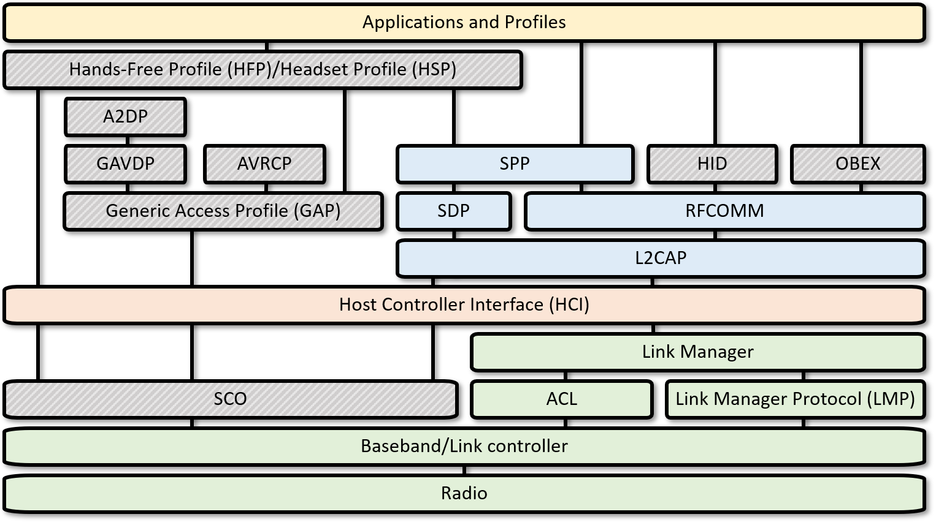

## L2CAP

L2CAP is an acronym that stands for Logical Link Control and Adaptation-layer Protocol. L2CAP has one main function in the system: it serves as a data packet multiplexor that lets you have multiple streamed connections from the higher level going into one interlaced set of packets going out the Radio. It obviously implements the de-multiplexor function as well, taking a single stream of interlaced packets and turning it back into complete streams on the other side of the link.

The L2CAP divides up the streams of data into L2CAP Channels that:

1. Divides up streams of data into smaller packets that will fit through the Radio.
2. Provides quality of service to each of the L2CAP channels.
3. Provides flow control.

## RFCOMM

RFCOMM was built as a wired RS232 replacement protocol. It supports all the normal wires for a serial port including Rx, Tx, CTS, RTS, DSR, DTR, CD and Ri. Depending on the implementation, RFCOMM gives you up to 60 Server Channels of streams of serial data. The protocol is built on top of L2CAP (a packet-based system). It appears to the Application developer with an API that makes it look like a UART.

## Serial Port Profile

The Serial Port Profile specifies all the protocols and procedures required to setup, discover and connect two virtual serial ports over an RFCOMM connection. If you are replacing a serial port interface like RS-232 or a UART with Bluetooth, then SPP is the profile you are looking for.

FYI, for iOS devices, the SPP is locked so it is only usable for MFi license holders. Their implementation is called iAP2.

# WICED Bluetooth Stack Events

The Stack generates Events based on what is happening in the Bluetooth world. After an event is created, the Stack will call the callback function which you registered when you turned on the Stack. Your callback firmware must look at the event code and the event parameter and take the appropriate action.

For your Basic Application these are the relevant BTM Events:

|  |  |
| --- | --- |
| **Event** | **Description** |
| BTM_ENABLED_EVT | When the Stack has everything going. This event data will tell if you it happened with WICED_SUCCESS or !WICED_SUCCESS. This is typically where you will launch most of your application code. |
| BTM_SECURITY_REQUEST_EVT | For BLE, this is used to retrieve the local identity key for RPA. For Classic BT you don't need to do anything for this event. |
| BTM_PAIRING_IO_CAPABILITIES_BR_EDR_REQUEST_EVT | The Stack is asking what IO capabilities this device has (Display, Keyboard etc.). You need to update the structure sent to you in the event data. |
| BTM_PAIRING_COMPLETE_EVT | The Stack is informing you that you are now paired. |
| BTM_ENCRYPTION_STATUS_EVT | The Stack is informing you that the link is now encrypted…or not depending on the event data. |
| BTM_PAIRED_DEVICE_LINK_KEYS_REQUEST_EVT | The Stack is asking you find and return the link key for the BDADDR that was sent in the event data. |
| BTM_USER_CONFIRMATION_REQUEST_EVT  (for numeric comparison bonding method) | The Stack is asking you to ask the user if the PIN you are displaying matches the PIN from the other side. This state should print the passkey (e.g. to UART or some other display). You can allow the user to verify the key only on the other side, or you can verify the user's input here before sending back the confirmation. |
| BTM_PASSKEY_NOTIFICATION_EVT  (for passkey entry method) | The Stack is notifying you that the other side of the connection wants a passkey. You should print the passkey (e.g. to UART or some other display) so that the user can enter it on the other device. |
| BTM_LOCAL_IDENTITY_KEYS_REQUEST_EVT | The Stack is asking you to read the local identify keys from the NVRAM and return them to the Stack. |
| BTM_PAIRING_IO_CAPABILITIES_BR_EDR_RESPONSE_EVT | The Stack is informing you of the I/O capabilities of the other side of the connection. |
| BTM_PAIRED_DEVICE_LINK_KEYS_UPDATE_EVT | The Stack is asking your firmware to store the BDADDR/Link Keys (which are passed in the event data). |

# Exercises

* 1. Create a Serial Port Profile Project

### Project Creation

For this example, you will need to:

1. Use the template in folder “templates/CYW920819EVB/ch06a_ex01_spp” to create a project called **ch06a_ex01_spp**.
2. Launch the Change Applications Settings dialog and set BT_DEVICE_ADDRESS = random.
3. Change the name of your device by editing the variable BT_LOCAL_NAME in the wiced_bt_cfg.c file.
   1. Hint: The default name is “spp test”, remember to use your initials in the device name so that you can find it in the list of devices that will be advertising.
4. Review the file spp.c to familiarize yourself with the way that everything is configured

### Testing

Once your project seems to be working, you can attach to it using Windows 7, Windows 10, MacOS or Android. Instructions for each are provided below.

Note that iOS does not support SPP directly, so you can't use an iPhone to test this project. Apple supports Classic Bluetooth with iAP2 (iPod Accessory Protocol) which works a bit differently than SPP and requires an MFi license.

### PC Instructions (Windows 7)

The first step is to pair your PC with the WICED Bluetooth device. Go to Control Panel -> Hardware and Sound -> Devices and Printers -> Add a Device.

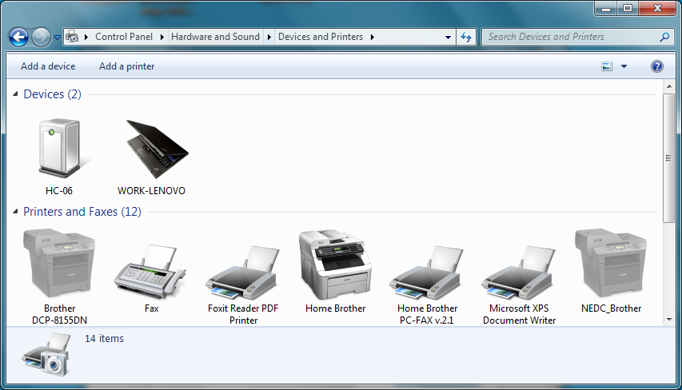

Wait until your device shows up in the list. Select it and click "Next".

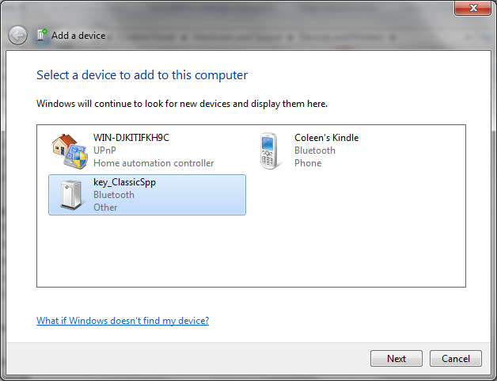

Compare the 6-digit code with the one displayed on your UART terminal. If the two numbers match, make sure "Yes" is selected and click "Next".

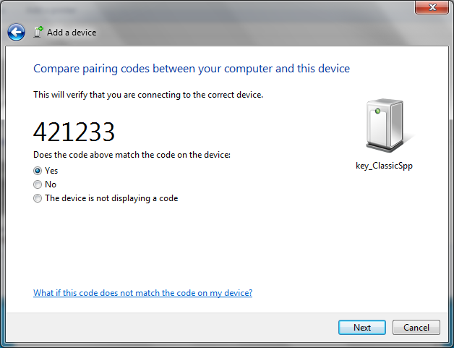

Click "Close" once the device has been added. Your device will now show up in the list of devices and drivers will automatically install.

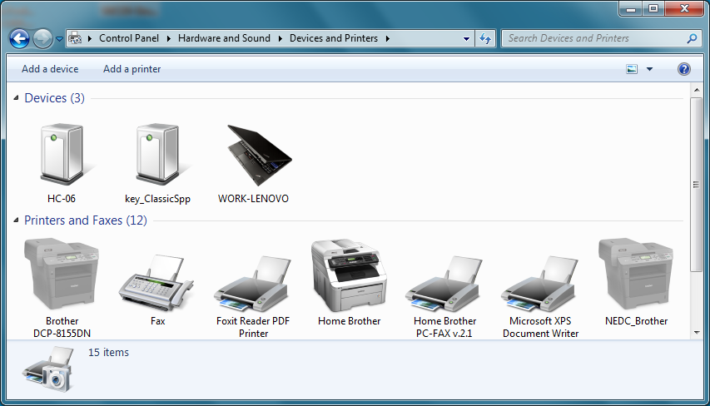

Go to the Device Manager and look under Ports (COM & LPT) to find the COM port for the SPP interface of your Bluetooth device. It will be listed as "Standard Serial over Bluetooth link". If you see multiple ports listed for Standard Serial over Bluetooth link, the lowest numbered port is the one you want to use.

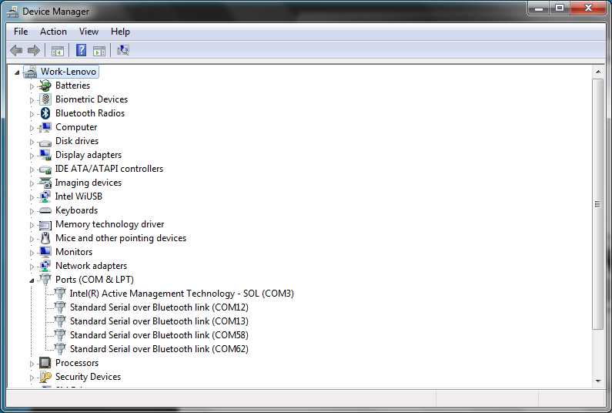

Open a serial terminal program of your choice (such as Putty) and connect to the SPP COM port. Now you can type in characters in the terminal window for the Bluetooth device and you will see them being received in the WICED kit by watching in terminal window connected to the kit's PUART.

When you are done testing, close the Bluetooth SPP terminal window and then go to Control Panel -> Hardware and Sound -> Devices and Printers. Right click on the WICED Bluetooth device, select "Remove Device" and click "Yes" to remove the device's paring information.

### PC Instructions (Widows 10)

For Windows 10 you can use the same procedure as for Windows 7. Alternately, in Windows 10 you have the option to install the "Bluetooth Serial Terminal" from the Microsoft App Store which provides a "slick" interface. That option is discussed here.

First, go to the Windows 10 Apps store (<https://www.microsoft.com/en-us/windows/windows-10-apps>), search for "Bluetooth Serial Terminal", and install it.

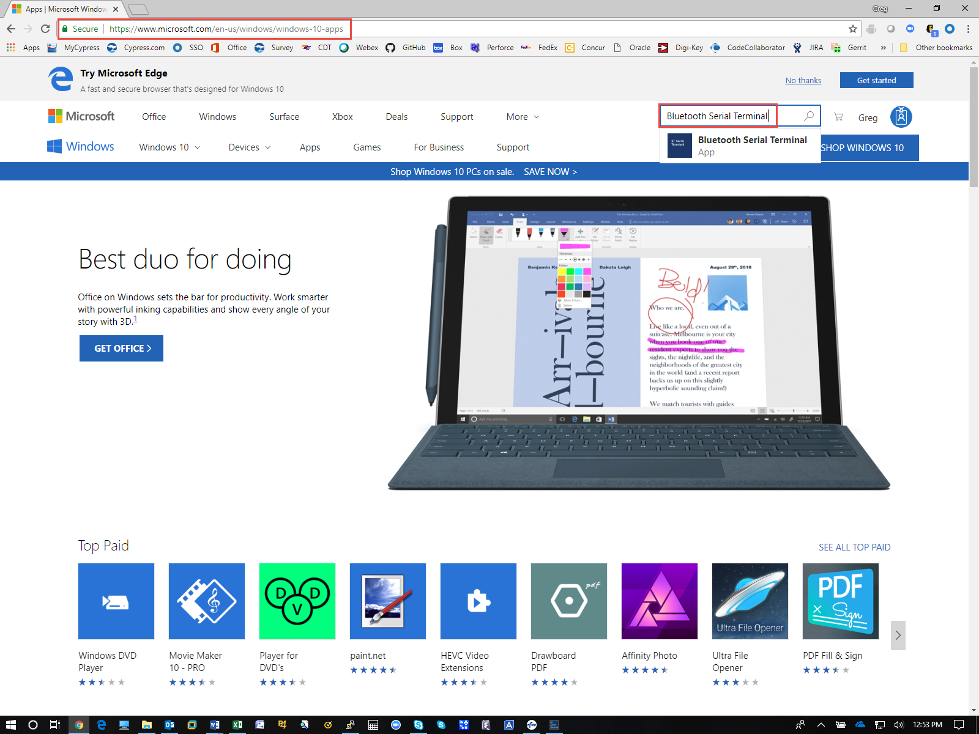

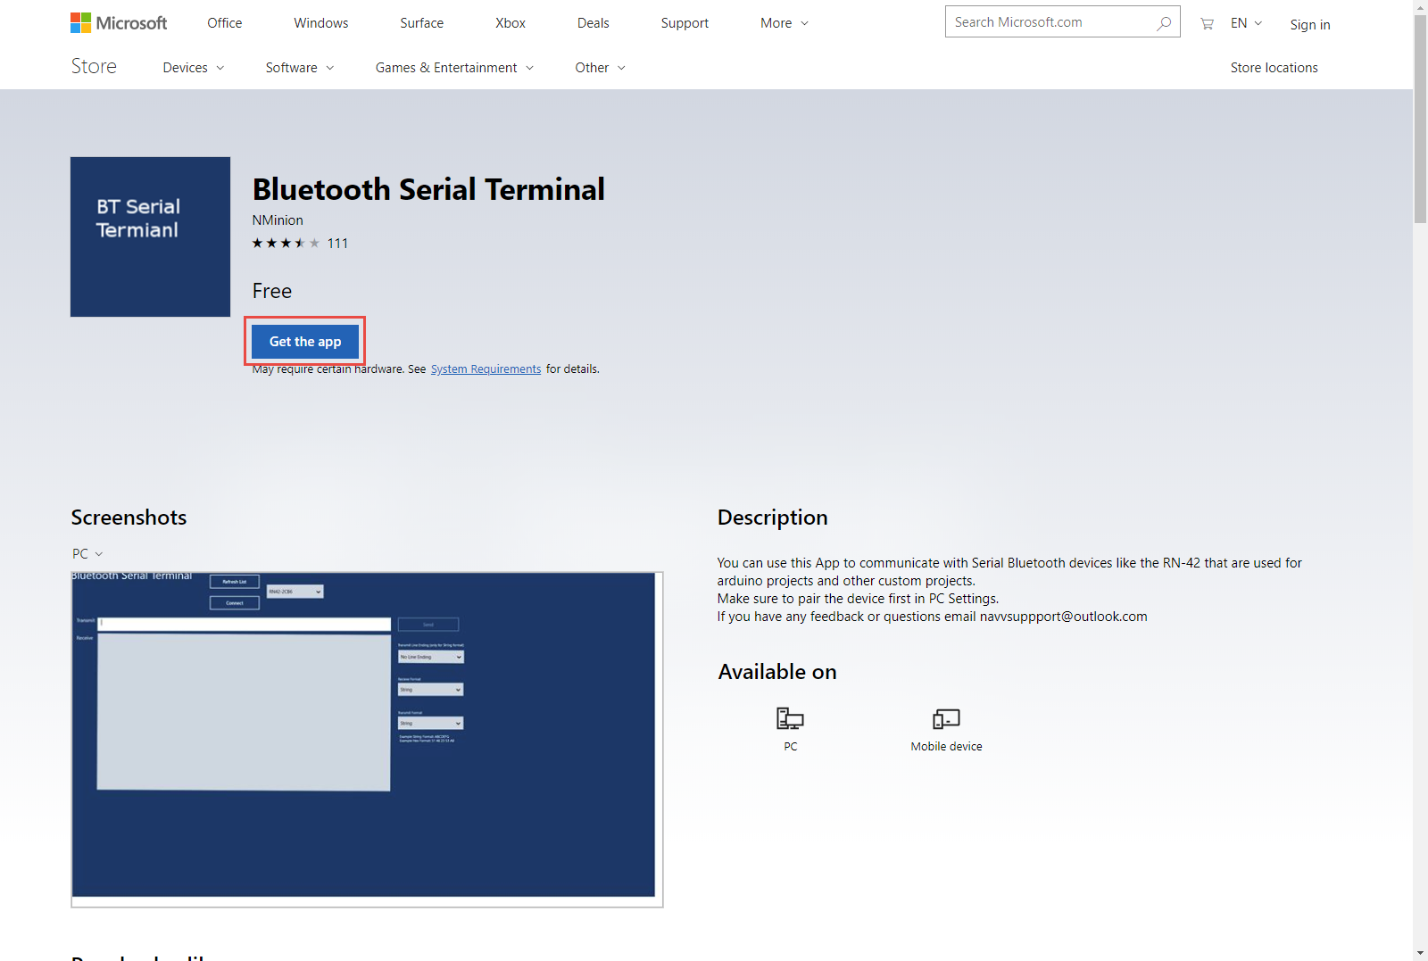

As with Windows 7, you need to pair with your device before it will show up as a serial port. To do this, go to *Settings -> Devices -> Add Bluetooth or other device -> Bluetooth*. When you see your device in the list, click on it. Compare the 6-digit code with the one displayed on your UART terminal. If the two numbers match, click on "Connect". Click "Done". Your device should now show up in the list of devices as "Paired":

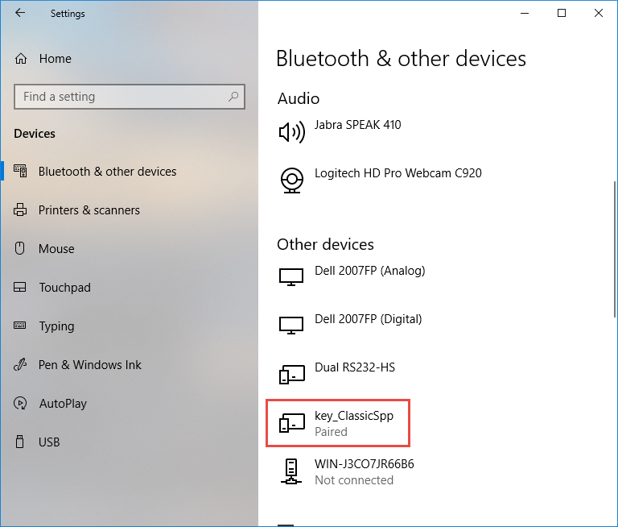

Now open the Bluetooth Serial Terminal app that you installed earlier. Your device should show up in the list. If not click "Refresh List".

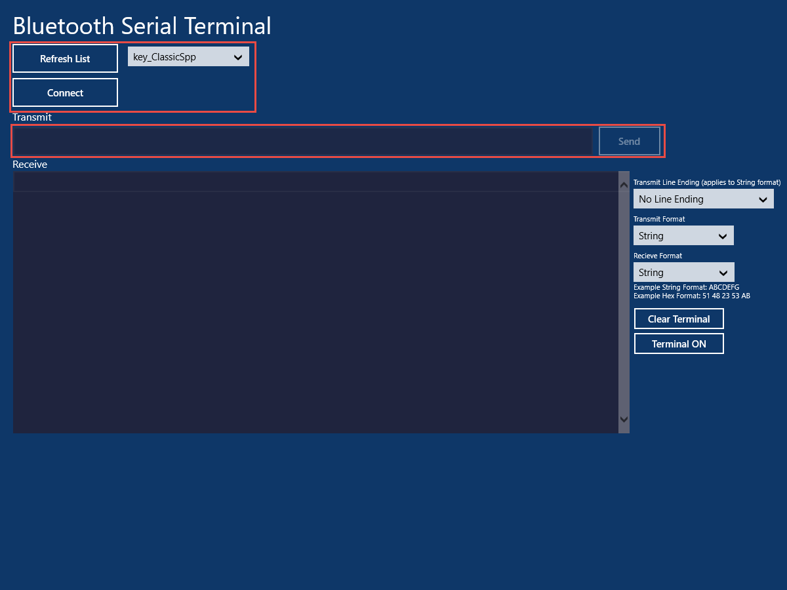

Once you see it in the list, click "Connect". Now you can type strings in the Transmit window and click "Send" to send them to the WICED SPP Project. Observe the strings being received in the WICED kit by watching in the UART terminal.

When you are done testing, click "Disconnect", close the Bluetooth Serial Terminal app and then go into the computer's Bluetooth settings to remove the device's paring information (Settings -> Devices -> <appname>_ClassicSpp -> Remove device -> Yes).

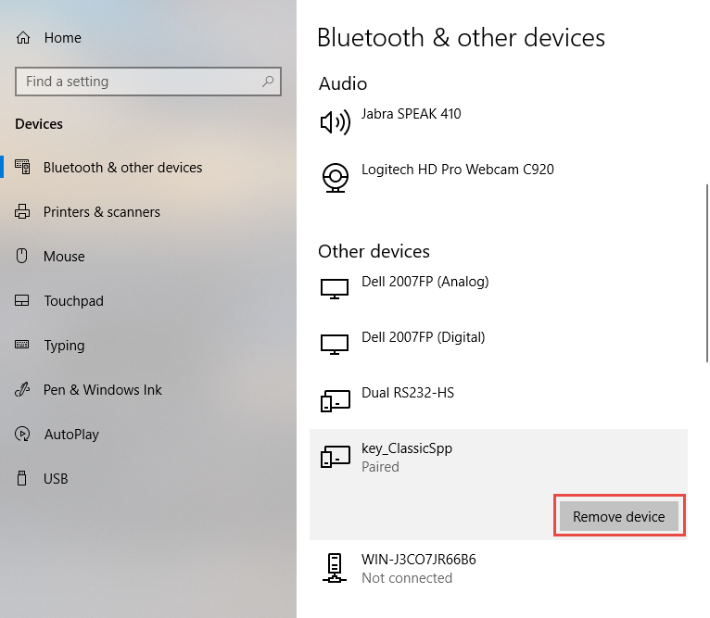

### Android Instructions

On an Android phone, you can install "Serial Bluetooth Terminal" from the Google Play Store. When you run the App, you will need to pair with your development kit. To do that open the menu (3 lines near the upper left corner) and tap on "Devices". From the Devices page, click on the "Gear" icon. This will take you to your phone's Bluetooth settings.

  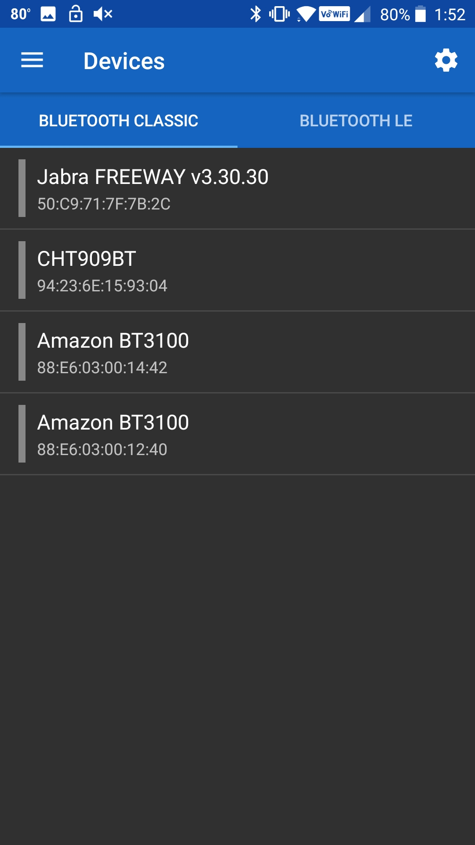

Find your device in the list and Pair with it (the exact procedure may be slightly different depending on the version of Android you are running).

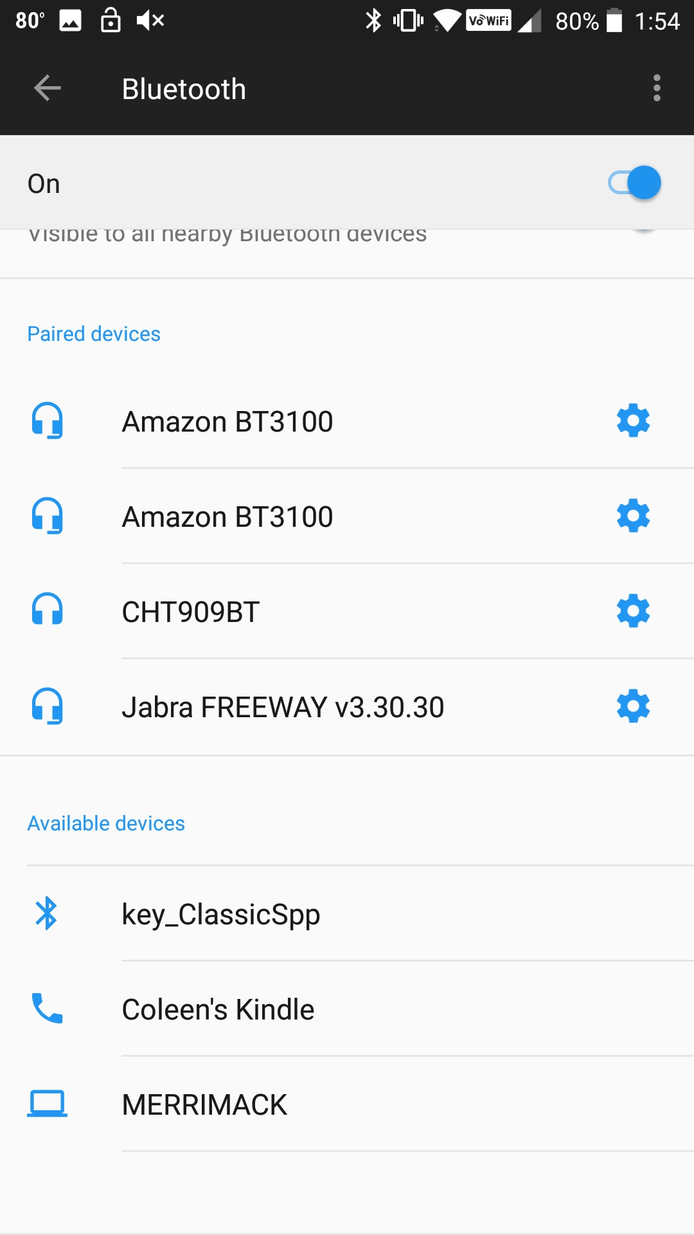 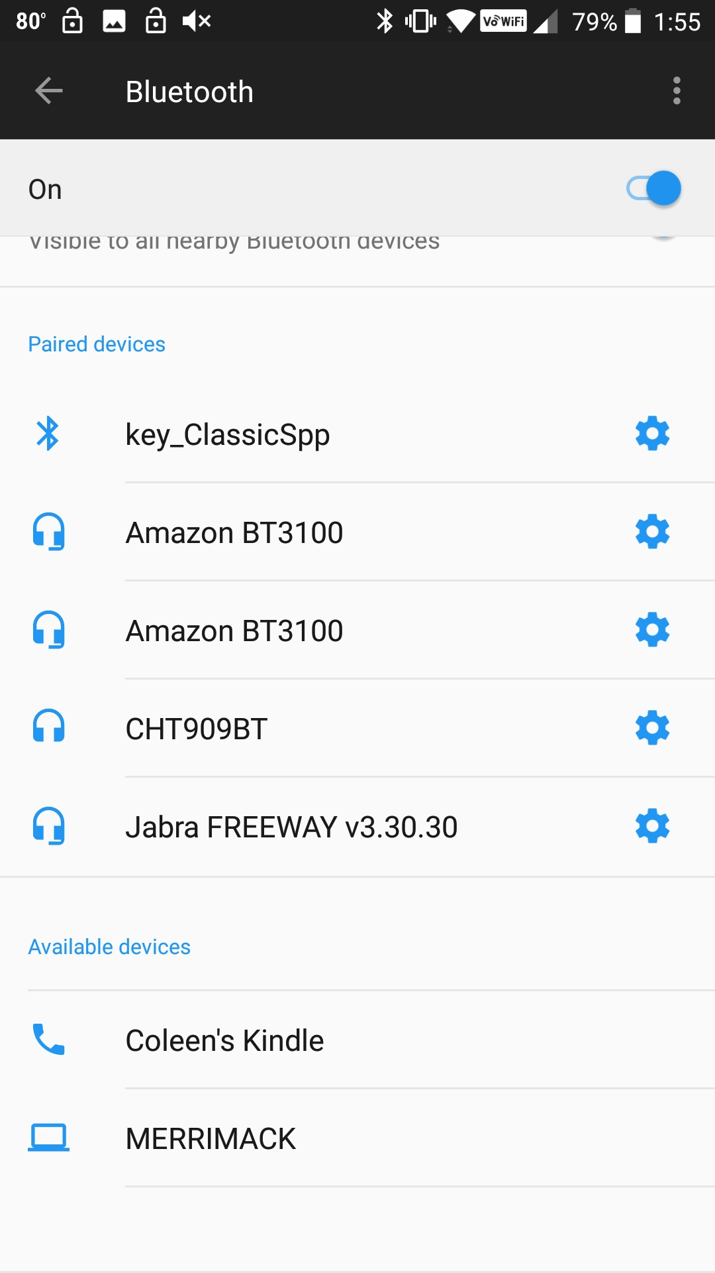

Once the device has been added, press the back arrow and you will see that your device appears in the Devices list. Tap on it to make it the active device (it will have a green bar to the left of the name when it is active). Then open the menu and select "Terminal" to see the blank terminal window. Next, tap the plug icon near the upper right corner to open the SPP server connection to your development kit. It will say "Connected" in the terminal window.

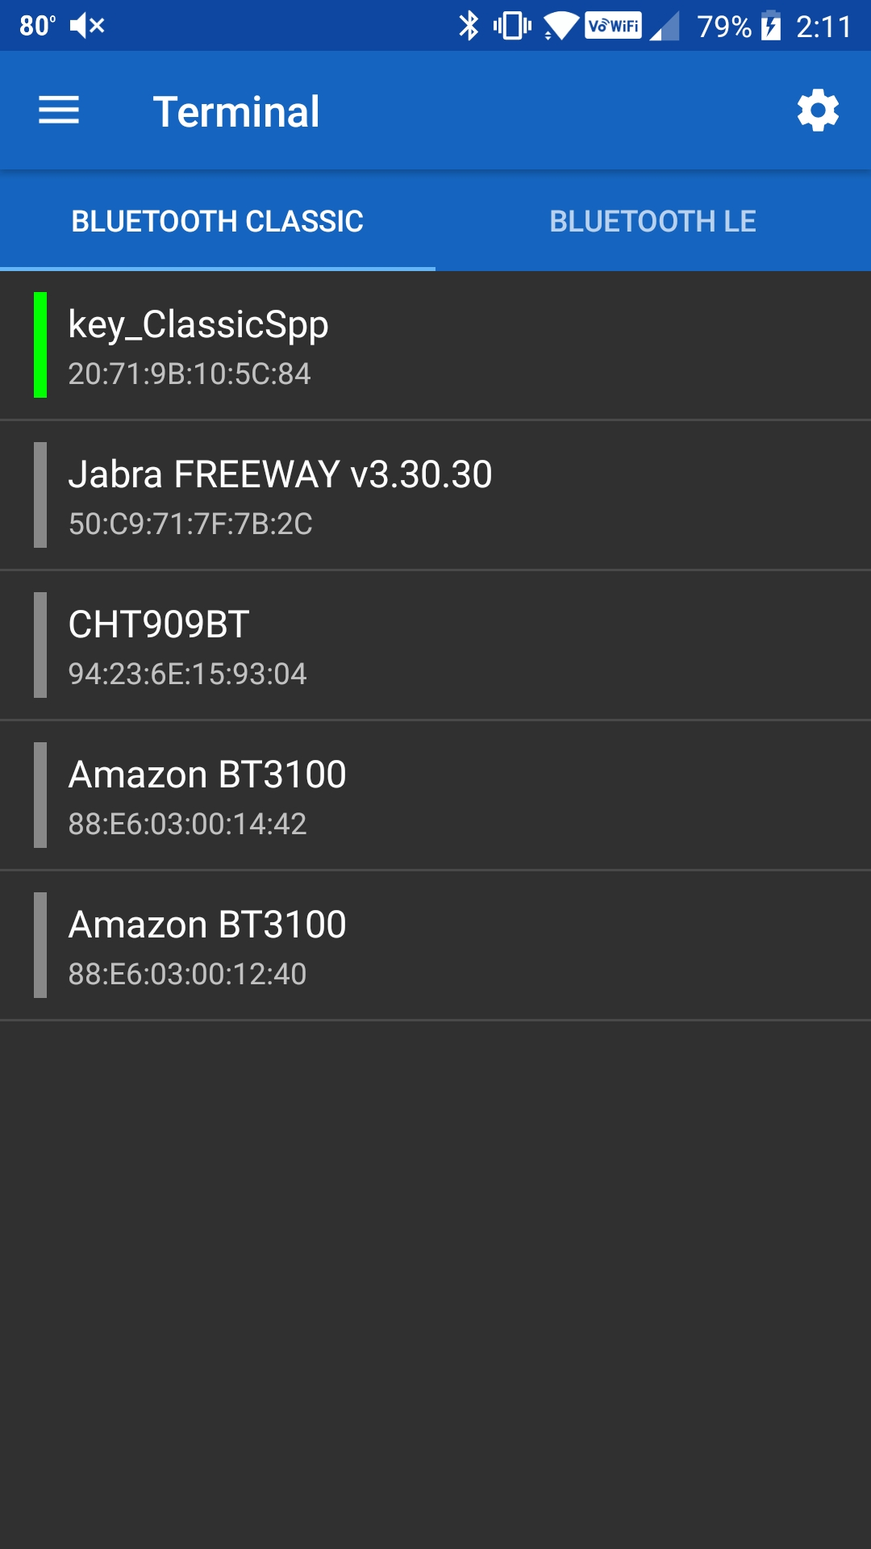  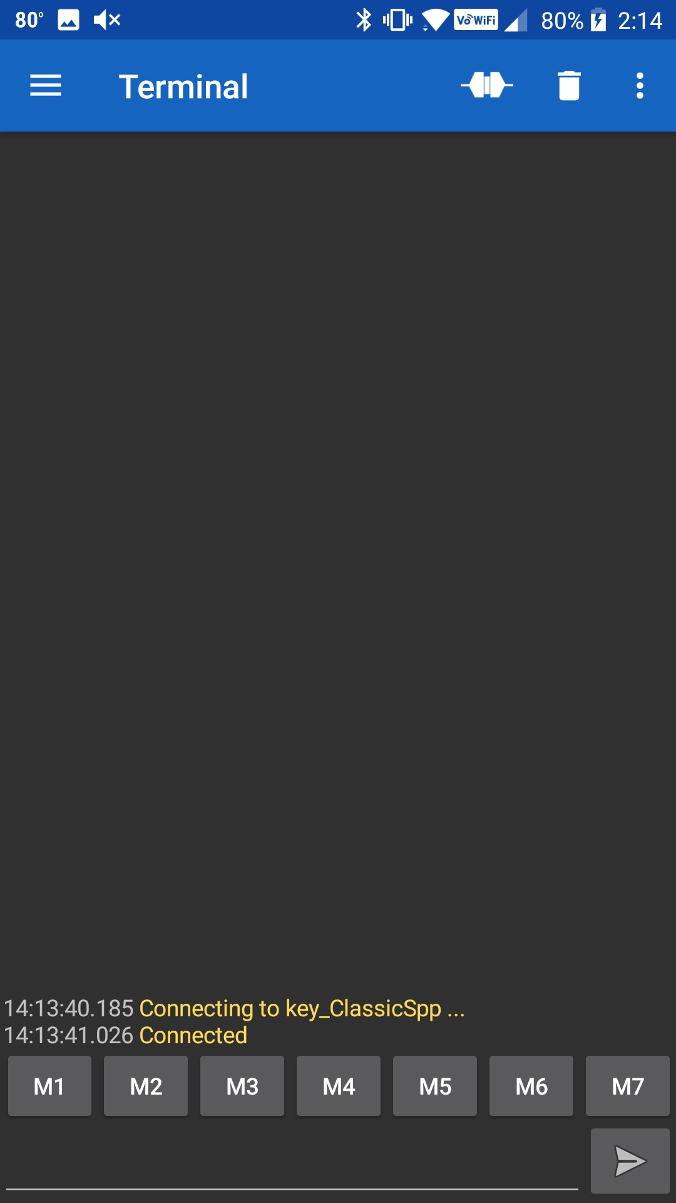

Now you can send data to the SPP server by entering it at the bottom of the window and clicking the Send arrow. You will see the data transmitted on the PUART terminal window for the kit.

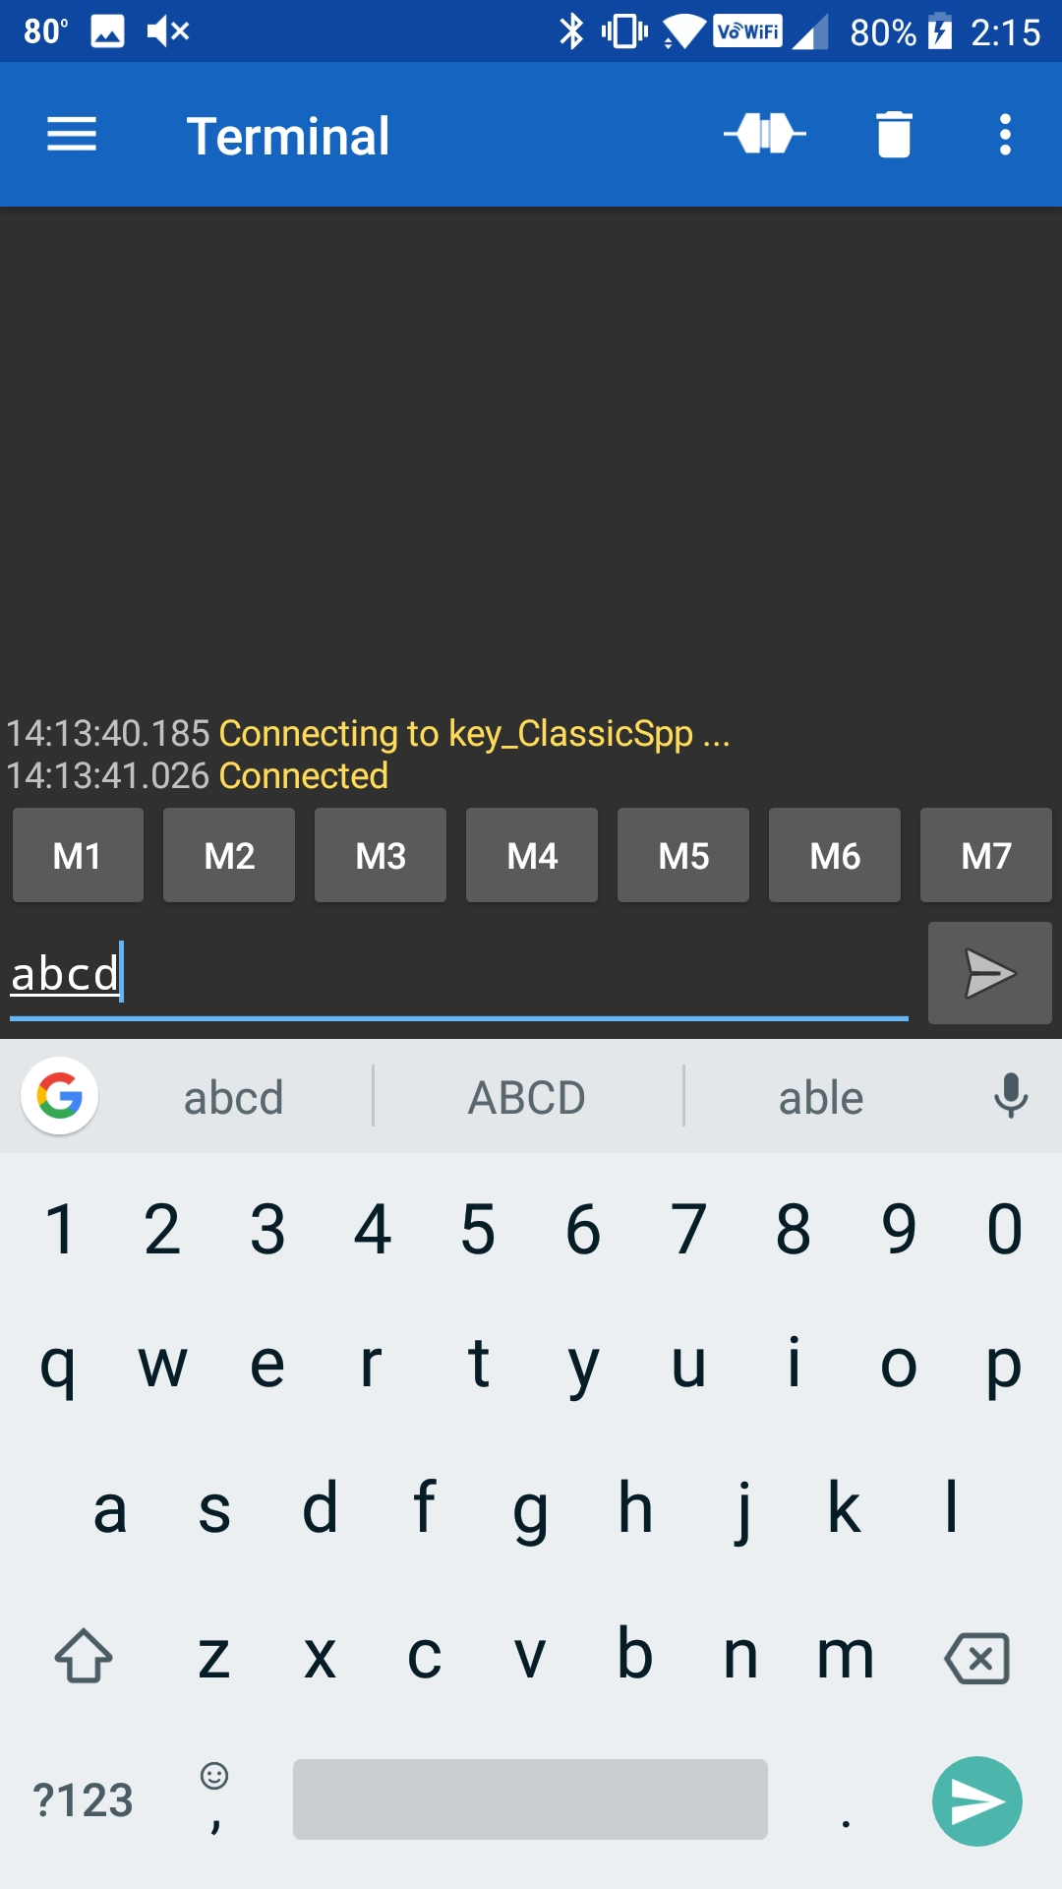 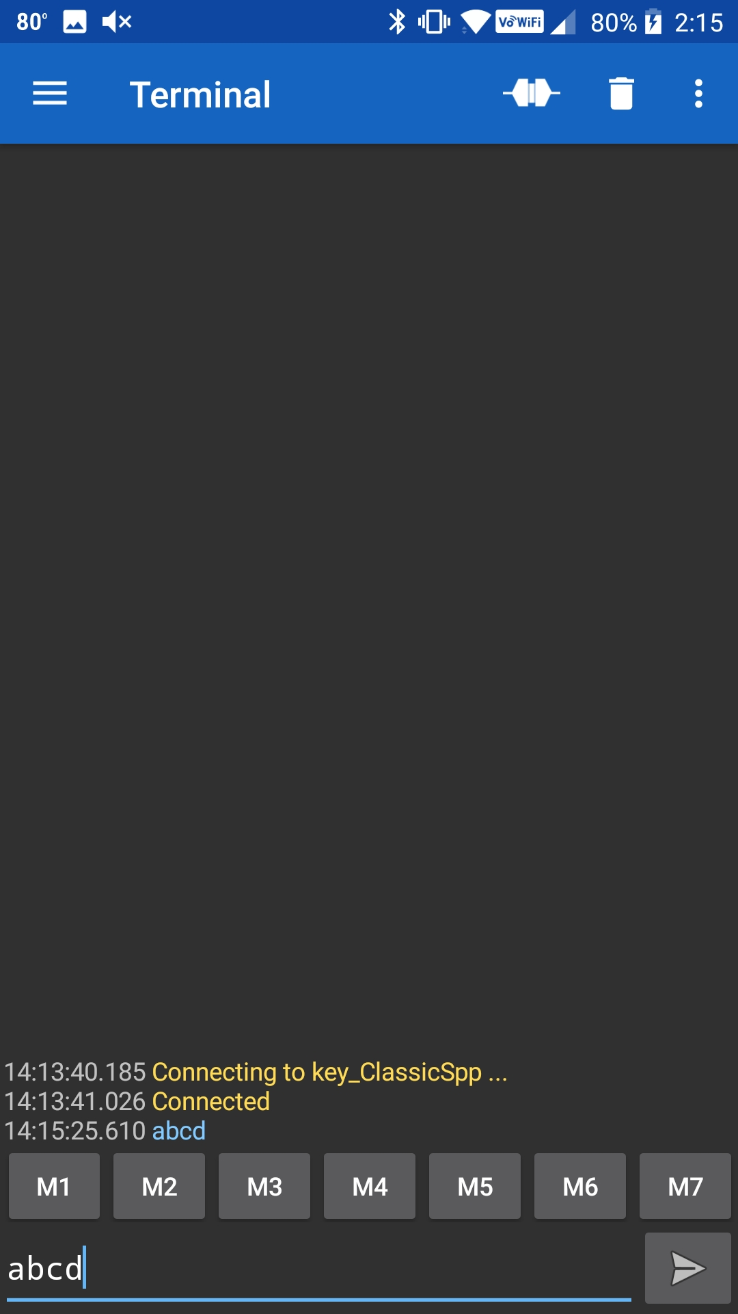

When you press the plug again, it will disconnect. You can then go back to the menu, select Devices, click on the Gear icon, and delete the Bonding information for your device (aka Forget) from the Bluetooth settings. Again, the exact procedure to forget the device will vary based on the version of Android you are running.

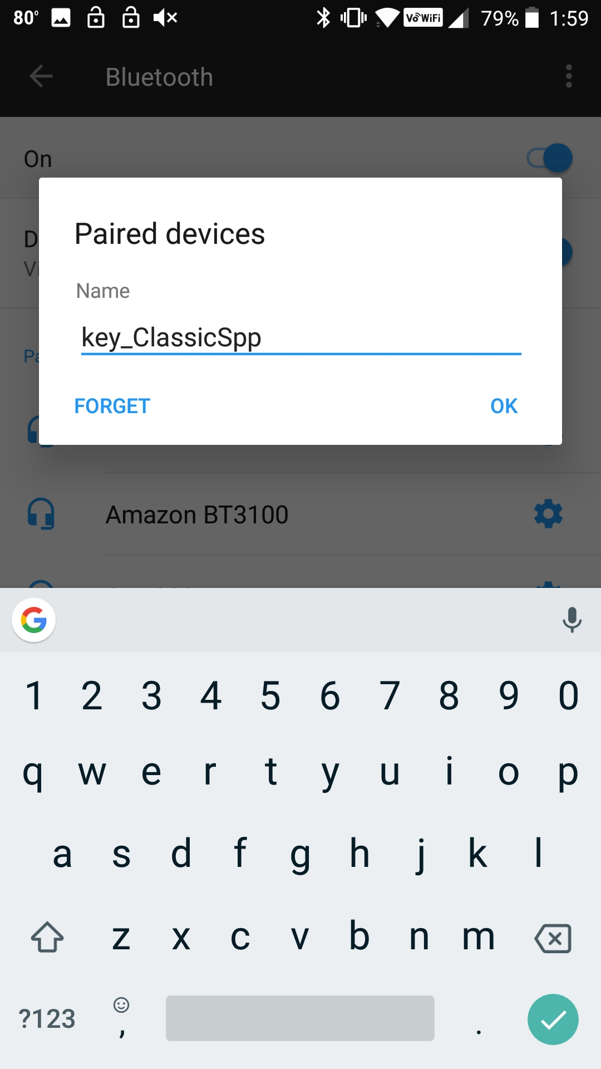

### Mac Instructions

Install "Serial" from Decisive Tactics onto your Mac. You can get it in the App Store.



Once you have programmed the development kit you need to connect to it from the Mac. In the Serial program choose File 🡪 Open Bluetooth.



Then click on your project and press "Select". This will pair to the development kit and open a window.



You will be asked to confirm the connection.



Once it is connected, everything you type will appear in the console window of the WICED Development kit. Below you can see that I typed "asdf".



To unpair your development kit, select the Bluetooth symbol and pick "Open Bluetooth Preferences"



Select your device and click the "X".

You will need to confirm that you want to remove the Bonding information from the Mac BT Stack.



* 1. Add UART Transmit

1. Use the template in folder “templates/CYW920819EVB/ch06a_ex01_spp” to create a project called **ch06a_ex02_spp**.
2. Launch the Change Applications Settings dialog and set BT_DEVICE_ADDRESS = random.
3. Change the name of your device by editing the variable BT_LOCAL_NAME in the wiced_bt_cfg.c file.
   1. Hint: The default name is “spp test”, remember to use your initials in the device name so that you can find it in the list of devices that will be advertising.
4. Modify spp.c to include a transmit function so that you can send data in both directions. You will read characters from the PUART terminal window so that when you type keys on your PC keyboard those values will be transmitted over Bluetooth to the Bluetooth Serial window.
   1. Hint: There is an example in the Peripherals chapter that receives characters from a terminal window. Refer to that if you need help determining how to read characters from the PUART.
   2. Hint: Add a new function called *spp_tx_data* to *spp.c* to send the data. It will take a pointer to the data to send and the length as parameters and will call the *wiced_bt_spp_send_session_data* function to send the data. You will call the *spp_tx_data* function from the main application whenever a keystroke is received from the PUART.
   3. (Advanced) Improve Security by Adding IO Capabilities (Yes/No)

In this exercise, we are going change the previous exercise to add confirmation on the WICED device. As before, a value will be displayed on both ends of the connection (WICED device and the phone or PC). The user will need to compare the two values and then perform the confirmation step on both devices before the connection is established.

Note: the phone or PC may or may not display the value and it may or may not require user input – this is up to the phone/PC application. In the case where the phone/PC automatically confirms the value you will still have to accept the connection on the WICED device end.

You will add the capability for the user to confirm that the numeric comparison value is correct on the WICED device using the "y" and "n" keys in the UART terminal.

To make this work you need to:

1. Use the template in folder “templates/CYW920819EVB/ch06a_ex03_spp_sec” to create a project called **ch06a_ex03_spp_sec**.
   1. In spp.c, change the pairing_io_capabilities_ble_request.local_iop_cap to BTM_IO_CAPABILITIES_DISPLAY_AND_YES_NO_INPUT.
   2. Add this code to the BTM_USER_CONFIRMATION_REQUEST_EVT it will print the value for the user to confirm.

WICED_BT_TRACE("\r\n********************\r\n" );

WICED_BT_TRACE( "\r\nNUMERIC = %06d\r\n\n", p_event_data->user_confirmation_request.numeric_value );

WICED_BT_TRACE("\r\n********************\r\n\n" );

* 1. Add a global variable called doCompare that is set when the user confirmation request is made and is reset after the user enters their Yes or No response.
  2. Add code to the BTM_USER_CONFIRMATION_REQUEST_EVT that will set doCompare.
     1. Hint: This event will provide the BDADDR for the master that is trying to pair. You should save this value (hint: memcpy) to a global since you will need it when you reply in the interrupt.
  3. In the spp_tx_data interrupt, if doCompare is set, look for "y" or "n" and then call wiced_bt_dev_confirm_req_reply() with the appropriate response. If doCompare is not set, then just send the value to the SPP interface as before.
     1. Hint: Look at the function declaration to determine what information you need to send with the reply based on which button was pressed.
     2. Hint: Make sure you remove the existing wiced_bt_dev_confirm_req_reply() call from the BTM_USER_CONFIRMATION_REQUEST_EVT.

Hint: You can rename the project/files in the new project if desired. If you want to change the name of the device that shows up on the Bluetooth scan, it is inside the file wiced_bt_cfg.c.

* 1. (Advanced) Add Multiple Device Bonding Capability

In this exercise, you will add the capability to store bonding information from multiple devices. You will need to make two changes to your current SPP implementation:

1. Use the template in folder “templates/CYW920819EVB/ch06a_ex04_spp_mult” to create a project called **ch06a_ex04_spp_mult**.
2. Handle saving multiple link keys into the NVRAM. Let's use 8 for the maximum number of saved link keys. Use one VSID to save a one-byte count of how many are being used. Then use VSID = VSID_Start+count to save each additional Address/Key Bonding pair.
3. Handle reading multiple link keys. When you get the event BTM_PAIRED_DEVICE_LINK_KEYS_REQUEST_EVT, the event data will be a pointer to a wiced_bt_device_link_keys_t structure. That structure contains the BDADDR of the device that is trying to pair. You need to search through the VSIDs to find the BDADDR of the saved link keys. If you find one that matches return it. Otherwise return a WICED_ERROR so that a new device can be added.
4. Update BTM_ENABLED_EVENT to load the number of bonded devices and to overwrite the next slot when the max number of devices has been reached.
5. Update BTM_PAIRING_COMPLETE_EVT to save the BDADDR of the host to NVRAM
   1. Remember to increment the number of bonded devices and the next free slot as well as save this information to NVRAM
6. Update BTM_ENCRYPTION_STATUS_EVT to search for the BDADDR trying to connect in NVRAM. If found restore values to a current host structure.
7. Add BTM_PAIRED_DEVICE_LINK_KEYS_UPDATE_EVT and write the code to save the new link keys to NVRAM.
8. Add BTM_PAIRED_DEVICE_LINK_KEYS_REQUEST_EVT and write the code to search for the BD_ADDR in NVRAM. If not return WICED_BT_ERROR and have the stack generate new keys and call BTM_LINK_KEYS_UPDATE_EVT so that they are stored.
9. Add BTM_LOCAL_IDENTITY_KEYS_UPDATE_EVT to save local keys to NVRAM and BTM_LOCAL_IDENTITY_KEYS_REQUEST_EVT to read local keys from NVRAM.

Hint: You can rename the project/files in the new project if desired. If you want to change the name of the device that shows up on the Bluetooth scan, it is inside the file wiced_bt_cfg.c.

Once you have the project completed, try bonding with two different devices (e.g. phone and PC). Connect and disconnect back and forth to verify that bonding information for both is retained and is used when reconnecting.

Hint: Look at chapter 4b exercise 6 if you get stuck.